SENTIMENT ANALYSIS ON PRODUCT & MOVIE REVIEWS

A Project Report Submitted in the
partial fulfillment of the requirements for the award of the degree of

BACHELOR OF TECHNOLOGY
In

DEPARTMENT OF COMPUTER SCIENCE AND ENGINEERING
By
AGASTYA PADMA SAI KUMAR | : 2420030077
VISHNU | : 2420030110
SRAVANTH | : 2420030079

Under the Esteemed Guidance of

Dr. N. Sunanda

Associate Professor

Department of Computer Science and Engineering

AY- 2026-2027

Semester: ______




K L (Deemed to be) University
DEPARTMENT OF COMPUTER SCIENCE AND ENGINEERING

Declaration

The Project Report entitled “SENTIMENT ANALYSIS ON PRODUCT & MOVIE REVIEWS” is a record of Bonafide work of AGASTYA PADMA SAI KUMAR – 2420030077, VISHNU – 2420030110, SRAVANTH – 2420030079 submitted in partial fulfillment for the award of B. Tech in Computer Science and Engineering to the K L University. The results embodied in this report have not been copied from any other departments/University/Institute.

AGASTYA PADMA SAI KUMAR – 2420030077
VISHNU – 2420030110
SRAVANTH – 2420030079

K L (Deemed to be) University
DEPARTMENT OF COMPUTER SCIENCE AND ENGINEERING

CERTIFICATE

This is to certify that the project report entitled “SENTIMENT ANALYSIS ON PRODUCT & MOVIE REVIEWS” is a bonafide work done and submitted by AGASTYA PADMA SAI KUMAR – 2420030077, VISHNU – 2420030110, SRAVANTH – 2420030079 in partial fulfillment of the requirements for the award of the degree of BACHELOR OF TECHNOLOGY in Department of Computer Science and Engineering, K L (Deemed to be University), during the academic year 2026-2027.

_____________________  Signature of the Guide  Dr. N. Sunanda  Associate Professor, CSE | _____________________  Course Coordinator  Dr. N. Sunanda  Department of CSE | _____________________  Head of the Department  Dr.P. Venkateswara Rao  Department of CSE

ACKNOWLEDGEMENT
The success in this project would not have been possible but for the timely help and guidance rendered by many people. Our wish to express my sincere thanks to all those who has assisted us in one way or the other for the completion of my project.

Our greatest appreciation to our Course Coordinator, and our guide Dr. N. Sunanda, Department of Computer Science and Engineering, which cannot be expressed in words for her tremendous support, encouragement and guidance for this project.

We express our gratitude to the DR.P.VENKATESWARA RAO Head of the Department of Computer Science and Engineering for providing us with adequate facilities, ways and means by which we are able to complete this project-based Lab.

We thank all the members of teaching and non-teaching staff members, and also who have assisted us directly or indirectly for successful completion of this project. Finally, we sincerely thank our parents, friends and classmates for their kind help and cooperation during our work.

AGASTYA PADMA SAI KUMAR – 2420030077
VISHNU – 2420030110
SRAVANTH – 2420030079

Abstract
Sentiment Analysis on Product & Movie Reviews is a Natural Language Processing (NLP) and machine-learning project that automatically identifies the opinion expressed in a written review. The system accepts a review and classifies it as positive or negative; a neutral class can be added when the dataset includes neutral labels. Product reviews help customers understand feedback about quality, usability, price, and service. Movie reviews reflect opinions about acting, story, direction, and entertainment. The proposed implementation uses text preprocessing, TF-IDF feature extraction, and Logistic Regression classification. A simple Streamlit interface allows users to select a review category, enter review text, and view the predicted sentiment. The project illustrates how unstructured text can be transformed into structured information for quick review analysis. The prediction is an automated estimate and may not correctly interpret sarcasm, context, or ambiguous language.

Keywords: Sentiment Analysis, NLP, Product Reviews, Movie Reviews, TF-IDF, Machine Learning, Logistic Regression.
Index
S. No. | Chapters | Topics | Page.no
 |  | Acknowledgement
 |  | Abstract
1 | Introduction | 1.1 Background of the project  1.2 Problem statement  1.3 Scope of the project  1.4 Objective(s)  1.5 Importance of the application  1.6 Target users/audience | 1-2
2 | System Requirements | 2.1 Hardware requirements  2.2 Software requirements  2.3 Development tools and frameworks | 3
3 | Technology Stack | 3.1 Front-end (Streamlit)  3.2 Back-end (Python, scikit-learn)  3.3 Database (dataset and model storage)  3.4 Version Control (Git, GitHub)  3.5 APIs or External services  3.6 Sentiment analysis  3.7 Natural language processing (NLP)  3.8 Text preprocessing  3.9 TF-IDF feature extraction  3.10 Logistic Regression  3.11 Evaluation metrics | 4-5
4 | System Architecture | 4.1 High-level architecture diagram  4.2 Description of each layer (frontend, NLP pipeline, model)  4.3 Deployment architecture | 6-7
5 | Design | 5.1 Wireframes or mockups  5.2 ER Diagram / Database schema | 8-9
6 | Implementation | 6.1 Module-wise implementation  6.2 Front-end logic (UI rendering, state management)  6.3 Backend logic (training, business logic)  6.4 Database connectivity  6.5 API integration  6.6 Authentication & Authorization | 10-12
7 | Features | 7.1 List of main features  7.2 How each feature works (user perspective + technical description)  7.3 Illustrative predictions  7.4 Application screenshots | 13-15
8 | Testing | 8.1 Postman testing (frontend/backend)  8.2 Integration testing  8.3 Tools used for testing  8.4 Test cases and results  8.5 Model evaluation | 16-17
9 | Deployment | 9.1 Steps to deploy  9.2 Environment configuration  9.3 Hosting of frontend and backend | 18
10 | Challenges & Limitations | 10.1 Issues faced during development  10.2 Solutions applied  10.3 Current limitations or known bugs | 19
11 | Future Enhancements | 11.1 Planned features  11.2 Possible integrations or optimizations | 20
12 | Conclusion | 12.1 Summary of the project  12.2 What was achieved  12.3 Skills learned during development | 21
13 | References | - Books, tutorials, APIs, documentation sites used | 22
14 | Appendices | - Screenshots of the app  - Sample code snippets  - Installation/setup instructions  - User manual or guide  - Certifications | 23-24

CHAPTER 1
Introduction
1.1 Background of the Project
Online shopping and movie platforms contain a large amount of user-generated review text. Reviews provide useful information about customer satisfaction, product performance, movie quality, and audience preferences. Manually reading thousands of reviews is time-consuming. Sentiment analysis applies Natural Language Processing (NLP) and machine learning to identify the polarity of opinions automatically.
1.2 Problem Statement
The main problem is that product and movie reviews are available in large quantities, making manual opinion analysis slow and difficult. The project develops a system that processes review text and predicts its sentiment category so users can understand the overall opinion more quickly.
1.3 Scope of the Project
The prototype focuses on English-language text reviews. It supports product and movie review categories and predicts positive or negative sentiment using a trained model. Neutral sentiment can be supported by adding neutral-labeled training examples. The prototype does not scrape review websites or guarantee perfect classification.
1.4 Objective(s)
- Understand the fundamentals of sentiment analysis and NLP.
- Prepare and preprocess review text.
- Convert text into numerical features using TF-IDF.
- Train a supervised machine-learning classifier.
- Predict sentiment for user-entered product and movie reviews.
- Present the prediction through a simple user interface.
- Evaluate the model using test data and basic metrics.
1.5 Importance of the Application
The system provides a quick summary signal of the opinion expressed in a review, which saves the time and effort of reading large numbers of reviews one by one. However, users should read the original reviews before making important decisions, because the prediction is an automated estimate.
1.6 Target Users/Audience
- Customers comparing products.
- Movie audiences exploring opinions.
- Businesses monitoring customer feedback.
- Students learning text analytics.
CHAPTER 2
System Requirements
2.1 Hardware Requirements
Minimum: dual-core processor, 4 GB RAM, and approximately 1 GB free disk space. Recommended: 8 GB RAM for comfortable development. Internet access is needed to install Python packages, but the trained prototype can run locally.
2.2 Software Requirements
- Operating System: Windows, Linux, or macOS.
- Python 3.10 or later (recommended).
- Libraries: pandas, scikit-learn, joblib, Streamlit.
- Editor/IDE: VS Code, PyCharm, Jupyter Notebook, or Google Colab.
- Browser: Chrome, Firefox, Edge, or another modern browser.
2.3 Development Tools and Frameworks
Python is used for the model and text-processing pipeline. pandas handles tabular data. scikit-learn provides TF-IDF and Logistic Regression. joblib saves the trained pipeline. Streamlit provides a lightweight web interface.
Tool / Framework | Purpose in the project
Python | Model and text-processing pipeline
pandas | Handling of tabular (CSV) data
scikit-learn | TF-IDF feature extraction and Logistic Regression
joblib | Saving and loading the trained pipeline
Streamlit | Lightweight web interface

CHAPTER 3
Technology Stack
3.1 Front-end (Streamlit)
The front-end is built with Streamlit, which provides a lightweight web interface for the project. The interface contains a review category selector (Product Review or Movie Review), a text area for entering the review, an Analyze Sentiment button, and a result area that shows the predicted sentiment.
3.2 Back-end (Python and scikit-learn)
The back-end and model logic are written in Python. scikit-learn supplies the TF-IDF vectorizer and the Logistic Regression classifier, which are combined into a single pipeline that converts raw review text into a sentiment prediction.
3.3 Database (Dataset and Model Storage)
The project does not use a database server. Labeled review examples are stored in a CSV file (reviews.csv) and handled with pandas. The trained pipeline is persisted with joblib as sentiment_model.joblib and loaded by the application when it starts.
3.4 Version Control (Git, GitHub)
Version control may be maintained using Git and GitHub.
3.5 APIs or External Services
The prototype does not call any external APIs or web services and does not scrape review websites. It relies only on the open-source Python libraries listed in Chapter 2.
3.6 Sentiment Analysis
Sentiment analysis, also called opinion mining, is the process of identifying the attitude or opinion expressed in text. In a basic classification task, reviews are labeled as positive, negative, or neutral. This project uses supervised learning: the model learns patterns from labeled examples and predicts the label of a new review.
3.7 Natural Language Processing (NLP)
NLP is a field of artificial intelligence concerned with processing and understanding human language. Review text is unstructured, so it must be converted into a representation that a machine-learning algorithm can process. Typical preprocessing includes lowercasing, removing unnecessary symbols, and handling whitespace. In this baseline implementation, scikit-learn's TF-IDF vectorizer performs tokenization and feature weighting.
3.8 Text Preprocessing
Preprocessing prepares text for analysis. Common steps include: (1) normalize case; (2) remove unwanted punctuation or HTML; (3) normalize whitespace; (4) optionally remove stop words; and (5) preserve important negation words such as "not" and "never." Over-cleaning can remove useful sentiment information, so preprocessing should be validated on the dataset.
3.9 TF-IDF Feature Extraction
TF-IDF (Term Frequency–Inverse Document Frequency) represents a word according to how often it occurs in a review and how informative it is across the collection. Terms common in many documents receive lower importance, while terms more distinctive to a review receive higher weight. The resulting sparse numerical vectors are used as input to the classifier.
A simplified expression is: TF-IDF(t,d) = TF(t,d) × IDF(t), where TF is the term frequency in document d and IDF reduces the weight of terms occurring in many documents.
3.10 Logistic Regression
Logistic Regression is a supervised classification algorithm. It learns weights for input features and estimates the probability of a class. For binary sentiment classification, it separates positive and negative reviews based on the TF-IDF feature vector. It is a strong, interpretable baseline for text classification and is efficient for sparse text features.
3.11 Evaluation Metrics
Accuracy is the fraction of correct predictions. Precision measures how many predicted examples of a class are correct. Recall measures how many actual examples of a class are found. F1-score is the harmonic mean of precision and recall. A confusion matrix shows correct and incorrect predictions by class. For imbalanced datasets, accuracy alone can be misleading.
CHAPTER 4
System Architecture
4.1 High-level Architecture Diagram
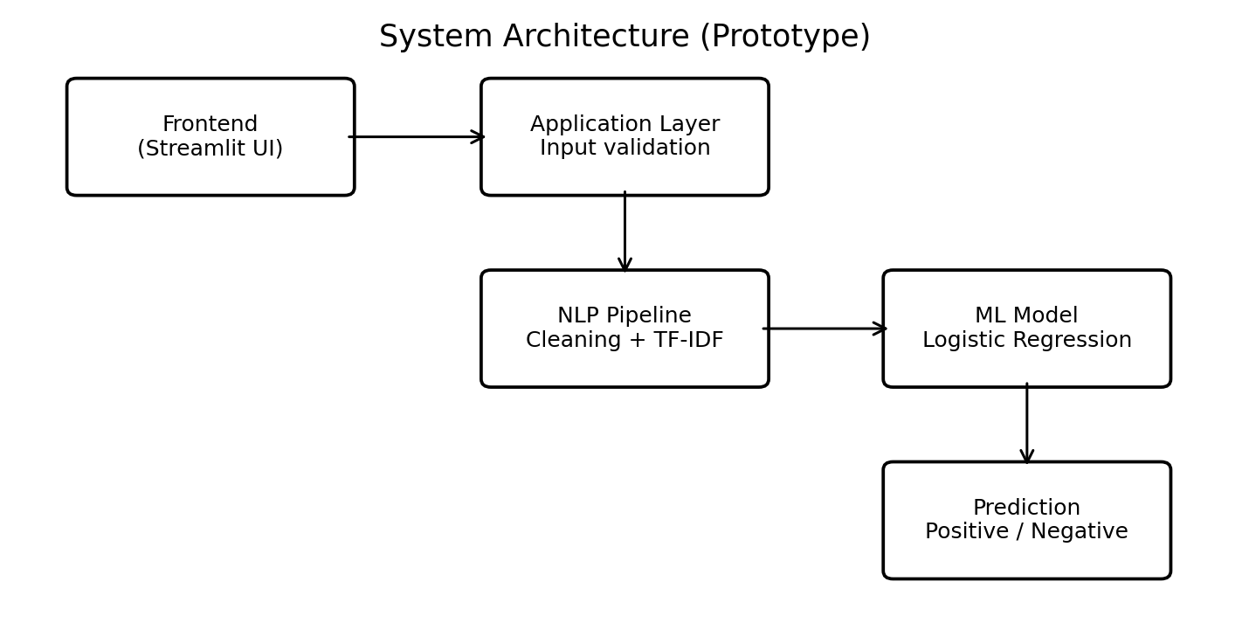
Fig No. 4.1 System Architecture (Prototype)
The frontend collects the review. The application validates the input and passes it to the NLP pipeline. The trained classifier returns the sentiment prediction, which is displayed to the user.
4.2 Description of Each Layer
- Frontend (Streamlit UI): collects the review category and review text from the user and displays the result.
- Application layer: validates the input (for example, an empty review shows a warning) and passes valid text to the NLP pipeline.
- NLP pipeline: performs text normalization and TF-IDF transformation.
- ML model: a trained Logistic Regression classifier that predicts the sentiment.
- Output: a positive or negative sentiment label shown to the user.
The data flow through these layers is summarized below.
Stage | Description
Input | Review category and review text.
Processing | Text normalization and TF-IDF transformation.
Model | Trained Logistic Regression classifier.
Output | Positive or negative sentiment label.
Training data | Labeled review examples used to fit the model.

4.3 Deployment Architecture
In the current version the entire system runs locally on a single machine. The Streamlit application loads the saved pipeline (sentiment_model.joblib) and serves the interface in the browser. No cloud services or CI/CD pipelines are used; deployment to a cloud hosting platform is listed under future enhancements.
CHAPTER 5
Design
5.1 Wireframes or Mockups
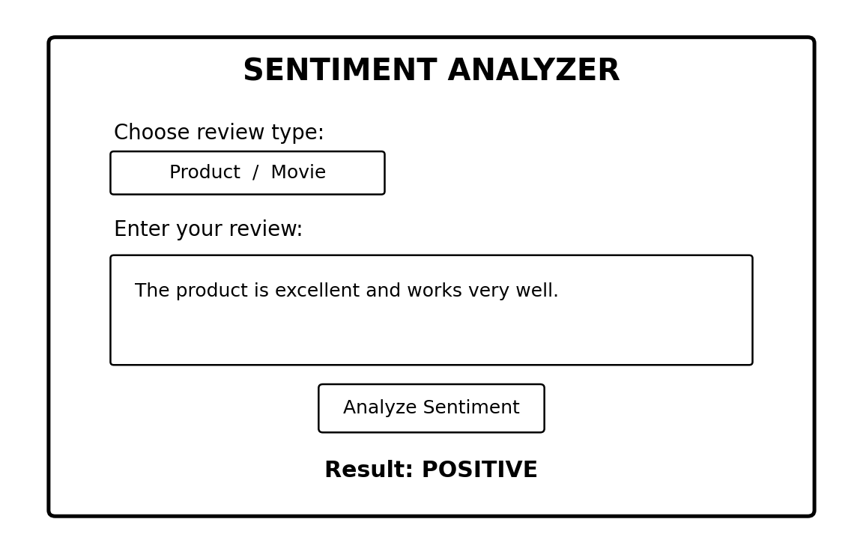
Fig No. 5.1 Illustrative User Interface Mockup
The figure above is a conceptual wireframe of the interface: a review type selector, a text box for the review, an Analyze Sentiment button, and the resulting prediction. Screenshots of the running application are given in Section 7.4.
5.2 ER Diagram / Database Schema
The project does not use a relational database, so there is no ER diagram. The only stored data is the labeled training dataset in a CSV file named reviews.csv, which has two columns.
Column | Type | Description
review | Text | The review text written by a user.
sentiment | Text (label) | The correct label of the review: positive or negative.

The example rows below are illustrative only; for meaningful performance, a larger, balanced, correctly labeled dataset should be used.
1. review,sentiment
2. "The product works great and the quality is excellent",positive
3. "Very useful item and easy to use",positive
4. "Terrible quality, it stopped working",negative
5. "Poor experience and disappointing product",negative
6. "The movie was amazing and the acting was brilliant",positive
7. "Wonderful story and excellent performances",positive
8. "The film was boring and the story was weak",negative
9. "Bad movie with poor acting",negative

CHAPTER 6
Implementation
6.1 Module-wise Implementation
The project is organized into four modules, each stored in its own file inside the project folder.
Module | File | Role
Dataset | reviews.csv | Labeled reviews with review and sentiment columns.
Model training | train_model.py | Loads data, trains and evaluates the pipeline, saves it.
Web application | app.py | Streamlit interface for entering a review and viewing the prediction.
Prediction script | predict.py | Optional command-line prediction (see Appendix).

The project folder structure is:
1. SentimentAnalysis/
2. ├── reviews.csv
3. ├── train_model.py
4. ├── sentiment_model.joblib # generated after training
5. ├── app.py
6. └── predict.py

6.2 Front-end Logic (UI Rendering, State Management)
The app loads the saved pipeline and accepts review text. It includes the product/movie selection as an interface category; this baseline model learns sentiment from text and does not train separate category-specific models. The model is loaded once and cached using Streamlit's resource cache, so it is not reloaded on every interaction. When the button is pressed, an empty review shows a warning; otherwise the review is passed to the model and the result is displayed.
app.py
1. import streamlit as st
2. import joblib
3.
4. @st.cache_resource
5. def load_model():
6. return joblib.load("sentiment_model.joblib")
7.
8. model = load_model()
9.
10. st.set_page_config(page_title="Sentiment Analysis", page_icon="💬")
11. st.title("Sentiment Analysis on Product & Movie Reviews")
12. st.write("Enter a review and predict whether its sentiment is positive or negative.")
13.
14. review_type = st.selectbox(
15. "Select review category",
16. ["Product Review", "Movie Review"]
17. )
18.
19. review_text = st.text_area(
20. "Enter your review:",
21. placeholder="Example: The product is excellent and works very well."
22. )
23.
24. if st.button("Analyze Sentiment"):
25. if not review_text.strip():
26. st.warning("Please enter a review before analyzing.")
27. else:
28. prediction = model.predict([review_text])[0]
29. st.subheader("Prediction")
30. if prediction == "positive":
31. st.success("Positive sentiment 😊")
32. else:
33. st.error("Negative sentiment 🙁")
34.
35. st.caption(f"Review category: {review_type}")
36. st.caption("Prediction is automated and may not understand sarcasm or context.")

6.3 Backend Logic (Training and Business Logic)
This code reads the labeled CSV dataset, splits it into training and testing data, builds a TF-IDF + Logistic Regression pipeline, evaluates it, and saves the trained pipeline.
train_model.py
1. import pandas as pd
2. import joblib
3.
4. from sklearn.model_selection import train_test_split
5. from sklearn.pipeline import Pipeline
6. from sklearn.feature_extraction.text import TfidfVectorizer
7. from sklearn.linear_model import LogisticRegression
8. from sklearn.metrics import (
9. accuracy_score, classification_report, confusion_matrix
10. )
11.
12. # 1. Load the labeled review dataset
13. data = pd.read_csv("reviews.csv")
14.
15. # Keep only rows with valid review text and sentiment labels
16. data = data.dropna(subset=["review", "sentiment"])
17. data["review"] = data["review"].astype(str)
18. data["sentiment"] = data["sentiment"].astype(str).str.lower().str.strip()
19.
20. # Expected labels in this baseline: positive and negative
21. data = data[data["sentiment"].isin(["positive", "negative"])]
22.
23. if data["sentiment"].nunique() < 2:
24. raise ValueError("Dataset must contain both positive and negative labels.")
25.
26. # 2. Split data. Stratify keeps class proportions similar in both sets.
27. X_train, X_test, y_train, y_test = train_test_split(
28. data["review"],
29. data["sentiment"],
30. test_size=0.20,
31. random_state=42,
32. stratify=data["sentiment"]
33. )
34.
35. # 3. Create a pipeline: text -> TF-IDF features -> classifier
36. model = Pipeline([
37. ("tfidf", TfidfVectorizer(
38. lowercase=True,
39. stop_words="english",
40. ngram_range=(1, 2),
41. max_features=20000
42. )),
43. ("classifier", LogisticRegression(max_iter=1000))
44. ])
45.
46. # 4. Train the model
47. model.fit(X_train, y_train)
48.
49. # 5. Evaluate on unseen test data
50. predictions = model.predict(X_test)
51. print("Accuracy:", round(accuracy_score(y_test, predictions), 4))
52. print("\nClassification Report:\n")
53. print(classification_report(y_test, predictions))
54. print("Confusion Matrix:\n", confusion_matrix(y_test, predictions))
55.
56. # 6. Save the complete pipeline (vectorizer + model)
57. joblib.dump(model, "sentiment_model.joblib")
58. print("Saved model as sentiment_model.joblib")

6.4 Database Connectivity
The dataset is read from reviews.csv using pandas. Rows without valid review text or sentiment labels are dropped, labels are converted to lower case, and only the positive and negative labels are kept. The training script raises an error if the dataset does not contain both classes. The trained pipeline (vectorizer and model) is saved with joblib as sentiment_model.joblib and loaded by the application.
6.5 API Integration
No external API is integrated. The application calls the trained pipeline directly through its predict function. An optional command-line script, predict.py, is provided in the Appendix for testing predictions without the web interface.
6.6 Authentication & Authorization
Authentication and authorization are not part of this prototype. The application runs locally, does not store user data, and does not require login.
CHAPTER 7
Features
7.1 List of Main Features
- Accepts user-entered review text.
- Allows the user to select Product Review or Movie Review.
- Preprocesses and vectorizes review text using the saved pipeline.
- Predicts positive or negative sentiment.
- Displays a readable result in the web interface.
- Supports model evaluation during training.
7.2 How Each Feature Works
Feature | User perspective | Technical description
Review input | The user types a review in the text box. | A Streamlit text area collects the text; an empty review shows a warning and the model is not called.
Category selection | The user chooses Product Review or Movie Review. | A Streamlit select box; the category is informational and the same model is used for both.
Preprocessing and vectorization | Happens automatically. | The saved pipeline lowercases text, removes English stop words, and builds TF-IDF features using single words and word pairs (maximum 20,000 features).
Sentiment prediction | The user clicks Analyze Sentiment. | The Logistic Regression classifier predicts positive or negative.
Result display | A positive or negative message is shown. | The app shows a success message for positive and an error-style message for negative sentiment.
Model evaluation | Not visible to the end user. | train_model.py reports accuracy, a classification report, and a confusion matrix on a 20% test split.

7.3 Illustrative Predictions
Sample review | Expected example sentiment | Reason
The product is excellent and easy to use. | Positive | Positive opinion words
The movie was fantastic and inspiring. | Positive | Positive evaluation
The product broke quickly and is poor quality. | Negative | Negative experience
The film was boring and disappointing. | Negative | Negative evaluation

These are illustrative examples, not measured outputs from a trained model. Actual predictions depend on the training dataset and model.
7.4 Application Screenshots
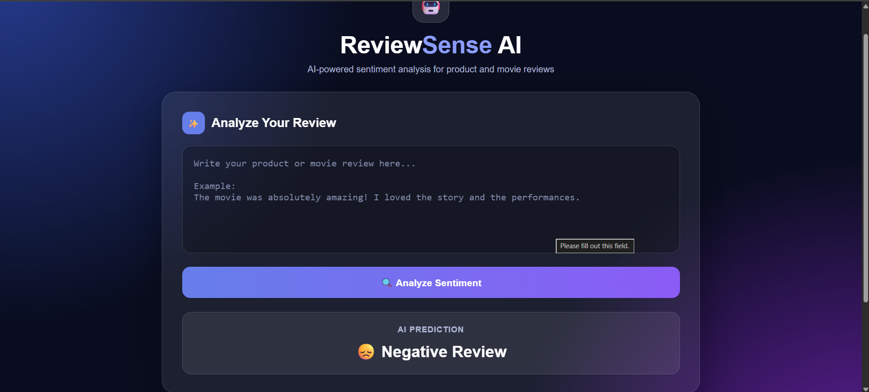
Fig No. 7.1 Application interface showing a Negative Review prediction
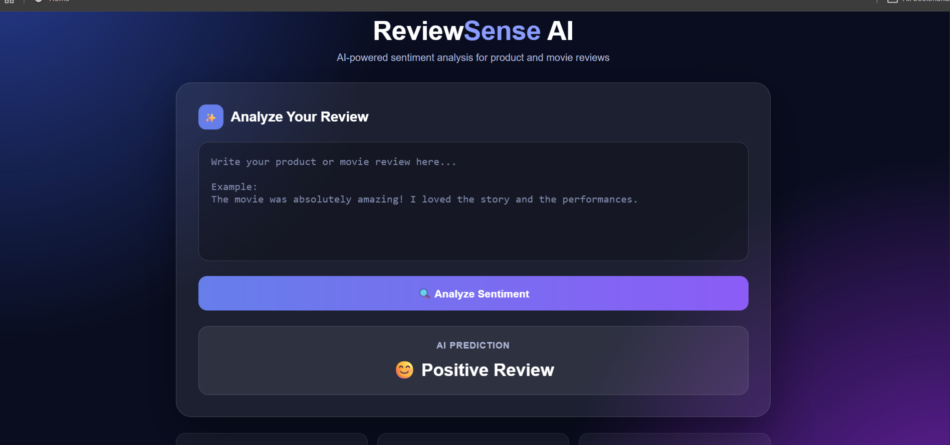
Fig No. 7.2 Application interface showing a Positive Review prediction
CHAPTER 8
Testing
8.1 Postman Testing (Frontend/Backend)
The project does not expose a REST API, so Postman testing is not applicable. The front-end and back-end are tested together through the Streamlit interface in the browser.
8.2 Integration Testing
Integration testing checks the complete flow: review entered in the interface, input validation, NLP pipeline, classifier, and displayed result. It also checks that the application reports an error when the trained model file is missing.
8.3 Tools Used for Testing
- Streamlit application in a web browser for interface-level testing.
- scikit-learn metrics (accuracy, classification report, confusion matrix) for model evaluation.
- The optional predict.py script for command-line checks.
8.4 Test Cases and Results
Test ID | Input | Expected behavior | Status
TC-01 | Positive review text | Predict positive if model learned similar patterns | To be tested
TC-02 | Negative review text | Predict negative if model learned similar patterns | To be tested
TC-03 | Empty review | Show warning; do not call model | Handled in app
TC-04 | Long review | Process text and return a prediction | To be tested
TC-05 | Review with punctuation | Accept text and predict sentiment | To be tested
TC-06 | Model file missing | App reports loading error; model file must be trained first | To be tested

8.5 Model Evaluation
Accuracy, precision, recall, F1-score, and the confusion matrix are produced by train_model.py on a separate test set that was not used for training. Final scores depend on the size and quality of the dataset used.
CHAPTER 9
Deployment
9.1 Steps to Deploy
- Install Python and create the project folder.
- Place reviews.csv in the project folder.
- Install the required packages.
- Run: python train_model.py
- Confirm that sentiment_model.joblib is created.
- Run: streamlit run app.py
- Open the local URL shown in the terminal (usually http://localhost:8501).
9.2 Environment Configuration
Python 3.10 or later is recommended. The required packages are installed with the following command:
1. python -m pip install pandas scikit-learn joblib streamlit

9.3 Hosting of Frontend and Backend
The front-end and the model logic run together in one Streamlit application on the local machine. The application is opened in a browser at the local URL. Deployment to a cloud hosting platform is a planned enhancement.
CHAPTER 10
Challenges & Limitations
10.1 Issues Faced During Development
- Review text contains spelling mistakes, slang, emojis, and informal language.
- Product and movie reviews use different vocabulary and context.
- A small dataset can lead to overfitting or unreliable results.
- Sarcasm and mixed sentiment are difficult to classify.
- Class imbalance can bias predictions.
10.2 Solutions Applied
- A stratified train/test split keeps class proportions similar in both sets.
- TF-IDF with single words and word pairs captures short phrases such as negations.
- Rows with missing text or labels are removed, labels are normalized, and the script checks that both classes are present.
- The application warns on empty input and caches the loaded model for faster responses.
- The report recommends using a larger, balanced, correctly labeled dataset for meaningful performance.
10.3 Current Limitations or Known Bugs
The baseline model uses a small set of sentiment classes and English-language text. It may misclassify sarcasm, negation, domain-specific expressions, or reviews containing both positive and negative opinions. The model's performance depends on dataset size, label quality, and domain coverage. The category selector is currently informational; the same trained model is used for both review types.
CHAPTER 11
Future Enhancements
11.1 Planned Features
- Add a neutral sentiment class using neutral-labeled data.
- Use separate product and movie datasets or domain-specific models.
- Add multilingual review analysis.
- Perform aspect-based sentiment analysis (e.g., price, quality, acting, story).
- Display sentiment charts and dataset-level summaries.
- Add review history and exportable reports.
11.2 Possible Integrations or Optimizations
- Try advanced models such as Linear SVM, LSTM, or transformer-based classifiers.
- Deploy the app to a cloud hosting platform.
CHAPTER 12
Conclusion
12.1 Summary of the Project
The project demonstrates a complete baseline workflow for sentiment analysis of product and movie reviews. Review text is cleaned and transformed into TF-IDF features, then classified using Logistic Regression. A Streamlit interface allows users to submit a review and view the predicted sentiment.
12.2 What Was Achieved
- A TF-IDF and Logistic Regression pipeline that classifies reviews as positive or negative.
- A saved model that can be reused by the web application and the prediction script.
- A simple web interface for entering reviews and viewing predictions.
- An evaluation step using a test split with standard classification metrics.
12.3 Skills Learned During Development
The project provides practical understanding of NLP, supervised learning, text vectorization, model evaluation, and application development. The results should be validated with a sufficiently large and representative dataset before real-world use.
CHAPTER 13
References
- scikit-learn User Guide: https://scikit-learn.org/stable/
- TF-IDF Vectorizer documentation: https://scikit-learn.org/stable/modules/generated/sklearn.feature_extraction.text.TfidfVectorizer.html
- Logistic Regression documentation: https://scikit-learn.org/stable/modules/linear_model.html#logistic-regression
- Streamlit documentation: https://docs.streamlit.io/
- pandas documentation: https://pandas.pydata.org/docs/
- joblib documentation: https://joblib.readthedocs.io/
CHAPTER 14
Appendices
14.1 Screenshots of the App
Screenshots of the running application are given in Section 7.4 (Fig No. 7.1 and Fig No. 7.2).
14.2 Sample Code Snippets
predict.py (optional prediction script)
1. import joblib
2.
3. model = joblib.load("sentiment_model.joblib")
4.
5. review = input("Enter a product/movie review: ").strip()
6. if not review:
7. print("Please enter review text.")
8. else:
9. result = model.predict([review])[0]
10. print("Predicted sentiment:", result.capitalize())

14.3 Installation/Setup Instructions
- Install Python.
- Create the project folder and add reviews.csv.
- Install the required packages.
- Train the model using train_model.py.
- Launch the application using Streamlit.
- Test positive, negative, empty, and longer reviews.
14.4 User Manual or Guide
- Start the application with: streamlit run app.py
- Open the local URL shown in the terminal in a web browser.
- Select the review category (Product Review or Movie Review).
- Type or paste the review into the text box.
- Click Analyze Sentiment.
- Read the predicted sentiment shown below the button. The prediction is automated and may not understand sarcasm or context.
14.5 Certifications
Certificates earned in connection with this project, if any, may be attached after this page.

